# Disk Collector

## Hardware

## 

## Design Considerations

* Must be able to reverse the collector to release unwanted disks of clear jams
* The collector should not operate when the shooter motor is running to prevent jams or other unwanted interactions

## Designs Considered

Considered the following:

* driver vs operator control of the collector
* push and hold to operate collector motor vs push-on / push off

In the end, a push and hold approach was chosen so that the operator would not have to remember the state of the collector (on, off, or reverse) nor look at the dashboard to determine its state. “Hands-off” the controls means the collector motor is stopped.

## Final Design

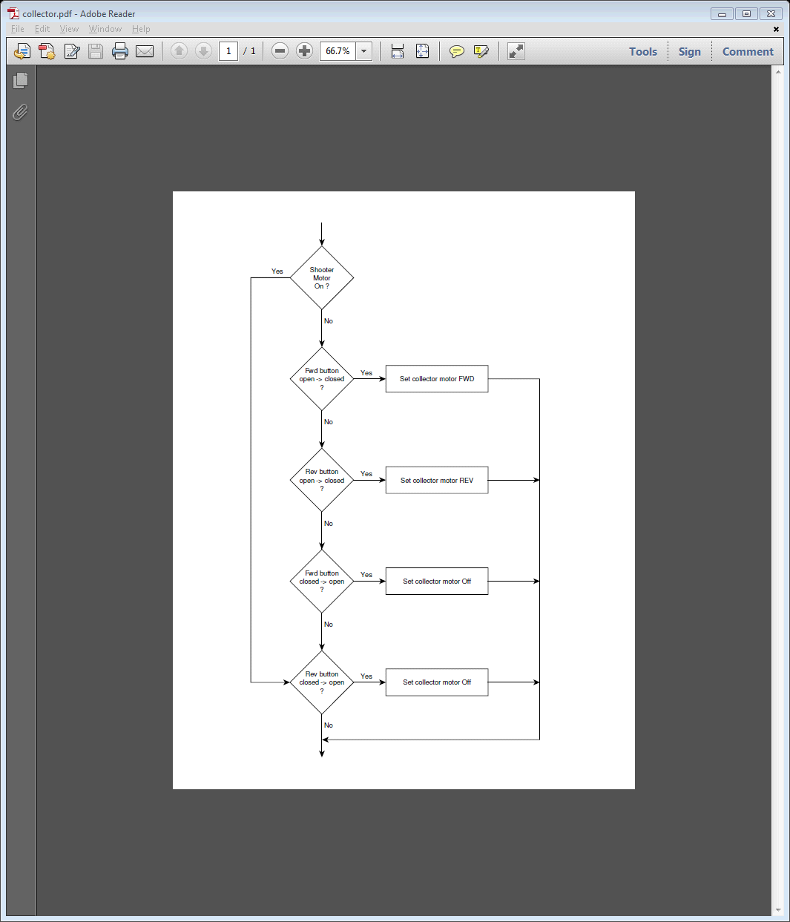

## User Interface

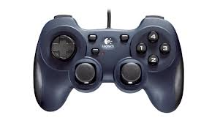

Button 4: push and hold to move collector forward

Button 2: push and hold to move collector backward